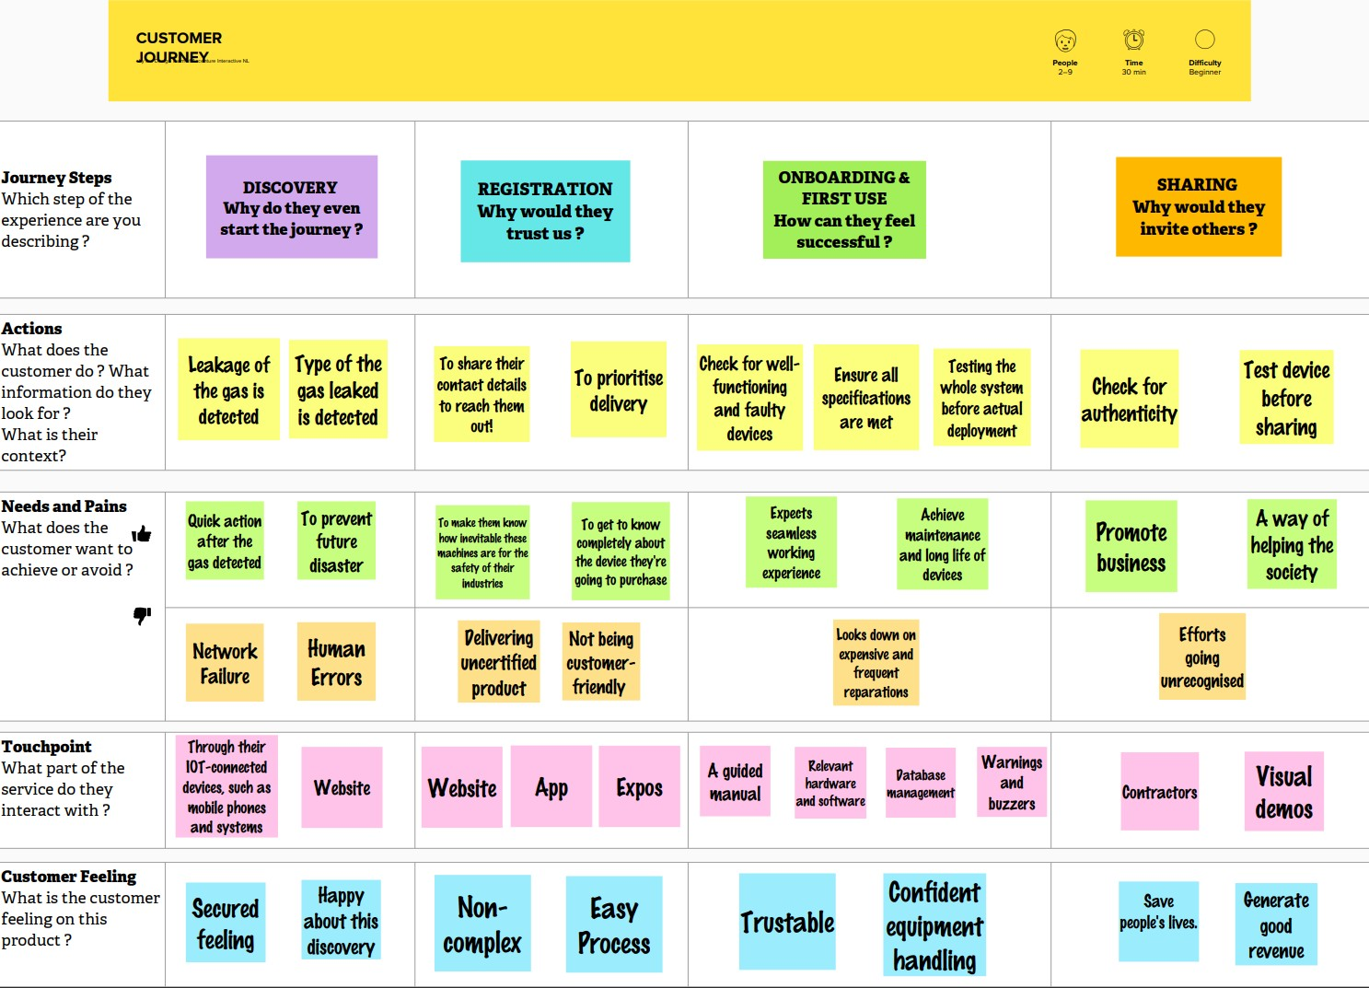
Project Design Phase-II Customer Journey

Date | 16 OCTOBER 2022
Team ID | PNT2022TMID12971
Project Name | GAS LEAKAGE MONITORING AND ALERTING SYSTEM FOR INDUSTRIES
Mark | 4 MARK

